APAA CONFERENCE BOOKING FORM
9th Annual Conference Physicians’ Assistants Anaesthesia (APA(A))
12th May 2017
Marriott Hotel, Cardiff.
Fee:
APA (A) Members – Trained - £75/ Trainee - £50
Non-Members - £90

Name of Delegate
APA(A) Member | ☐ yes  ☐ no
Grade/Title | ☐Trainee PA(A)  ☐Qualified PA(A)  ☐Other (e.g. consultant/speciality doctor) please state ………………………………….
Contact email
Contact phone number
Contact Address
Preferred payment method  (please indicate one) | ☐ PayPal  ☐ BACS  ☐Invoice to trust – Please provide details.  ☐ cheque to APA(A)

Special Dietary Requirements: (please state) ……………………………………………………………….
Invoice details: ………………………………………….………………....................................................
…………………………………………………………………………………………………………………………………
Please return this form to Lisa.churchill@wales.nhs.uk
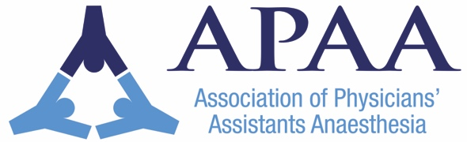
Payment can be made via;
PayPal at info@anaesthesiateam.com, BACS, invoice to your trust, or by cheques to‘APA(A)’.

