APAA CONFERENCE BOOKING FORM
10th Annual Conference
Physicians Assistant - Anaesthesia
4th May 2018
IET Teacher Building, ST Enoch Square, Glasgow G1 4DB
APPA Members - PA/A £75
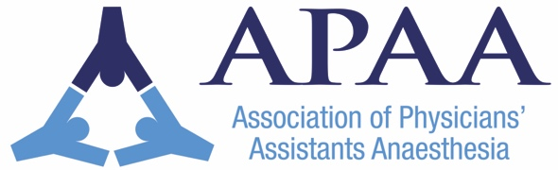
Trainee £50
Non-Members £90
Name of Delegate
APAA Member | ☐ yes  ☐ no
Grade/Title | ☐Trainee PA(A)  ☐Qualified PA(A)  ☐Other (e.g. consultant/speciality doctor) please state ………………………………….
Contact email
Contact phone number
Contact Address
Preferred payment method  (please indicate one) | ☐ PayPal  ☐ BACS  ☐Invoice to employer – Please provide details.  ☐ cheque to APA(A)

Special Dietary Requirements: (please state) ……………………………………………………………….
Invoice details: ………………………………………….………………....................................................
………………………………………………………………………………………………………………………
Please return this form to: pa.a.conference10@gmail.com or return to
A O'Neill . Anaesthetic Department. Hairmyres Hospital. Eaglesham Road. East Kilbride G75 8RG
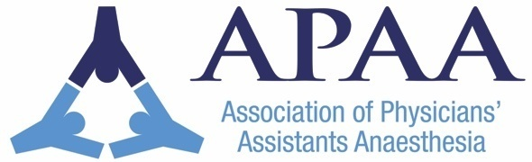
Payment can be made via;
PayPal at info@anaesthesiateam.com, BACS, invoice to your employer or by cheque to ‘APA(A)’.

